Documentation

Team: Music Database Interface

Team Members: Touhar Fang, Chee Nou Lee, Steven Lee

Professor Lucas Phan

IS183 2PM-3:50PM

Project Specifications:

* Website:
  + Login page.
  + Purchasing music.
  + Playing sample music.
  + Playing full music from purchase.
  + About Us page.
  + Contact page.
* Database:
  + Song:
    - Song Title Name
    - Artist Name
    - Genre
    - Album
    - Year
  + Artist
    - Artist Number
    - Artist Name
    - Artist Address
  + Customer
    - Name
    - Address
  + Employee
    - Employee Number
    - Employee Name
    - Employee Address

API Database Specifications:

Description: get all songs

Method: POST

ENDPOINT http://localhost:4200/api/music

Params: Null/None

Request Payload: NONE

Reponse:

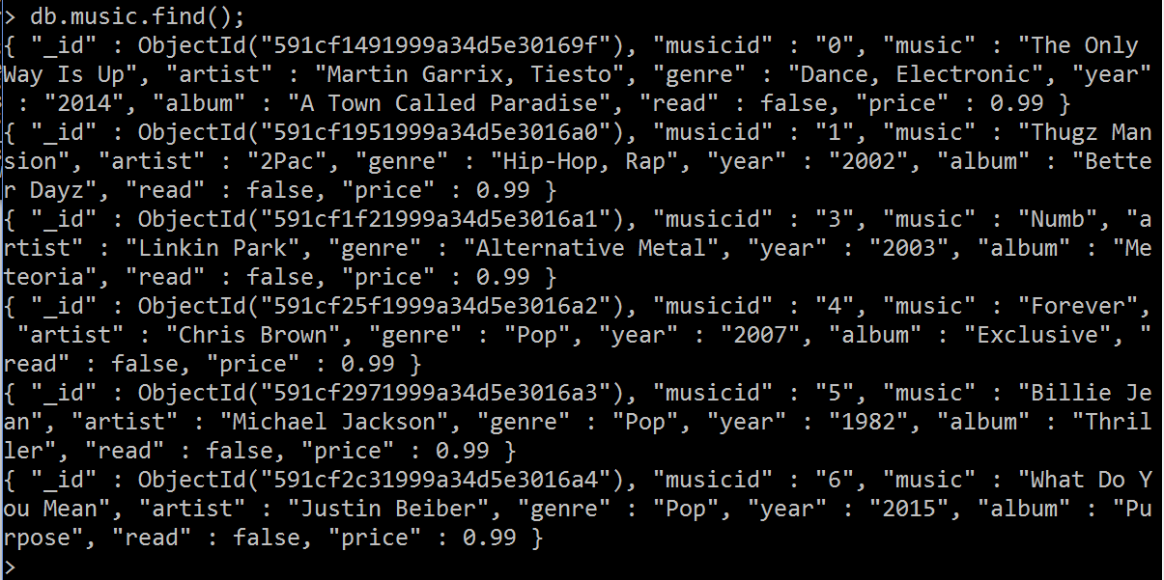

Databases ER-Diagram

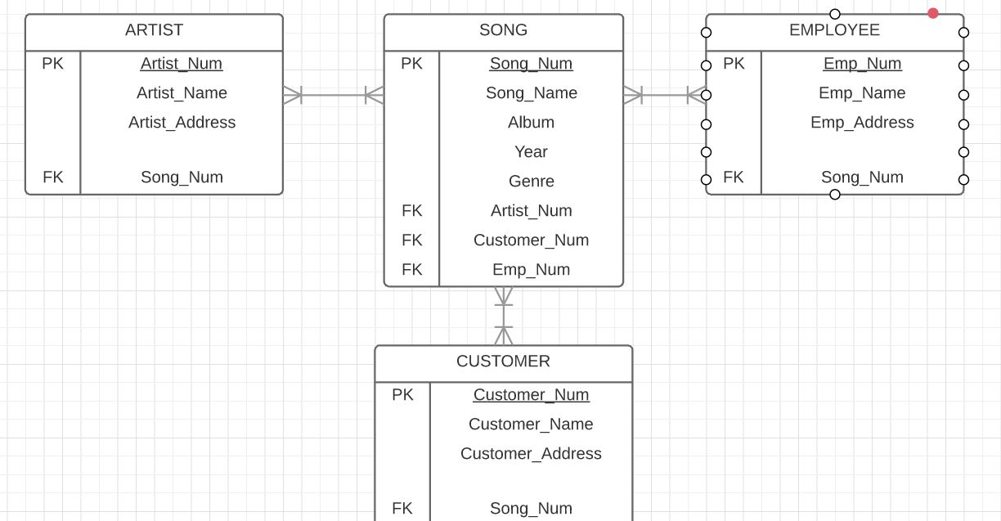

Project Wireframes / Mockups

Login page: 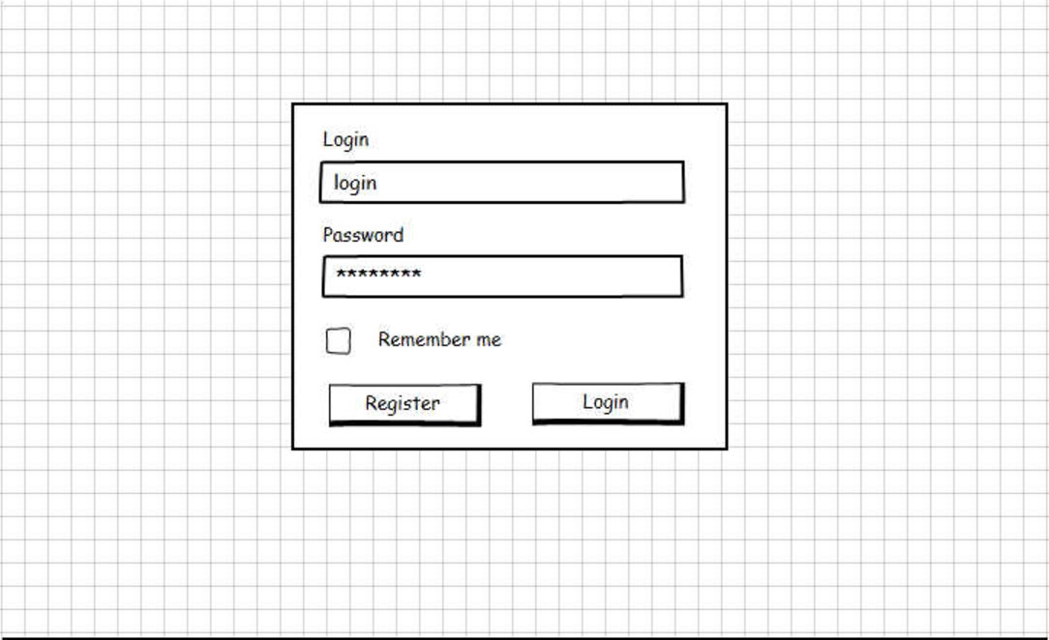Main page: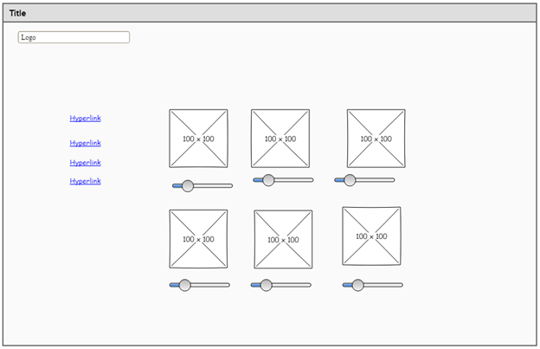

Project Final Products:

Login page: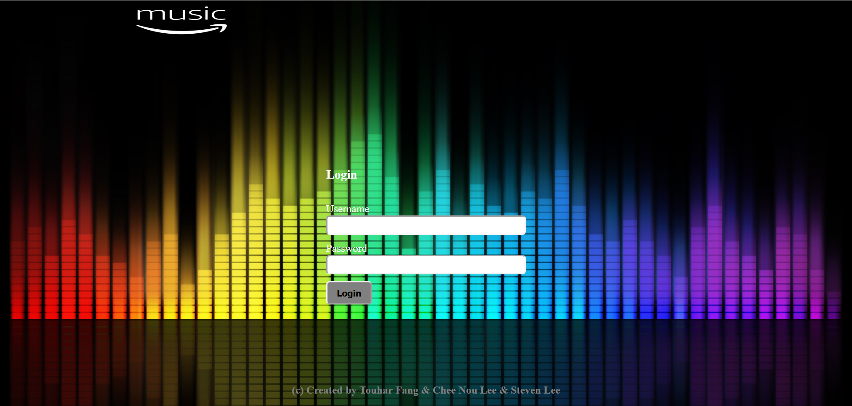

Main page: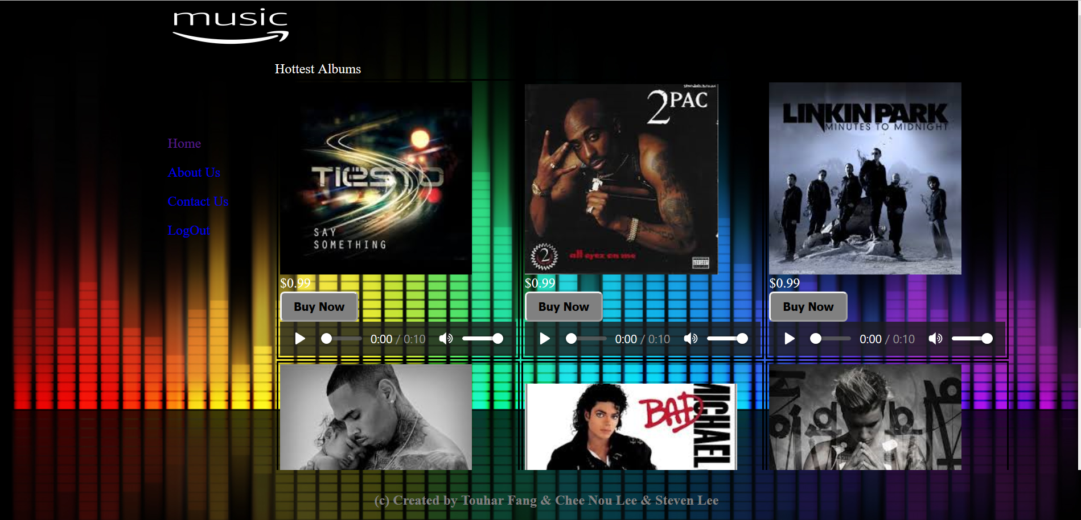

About Us page: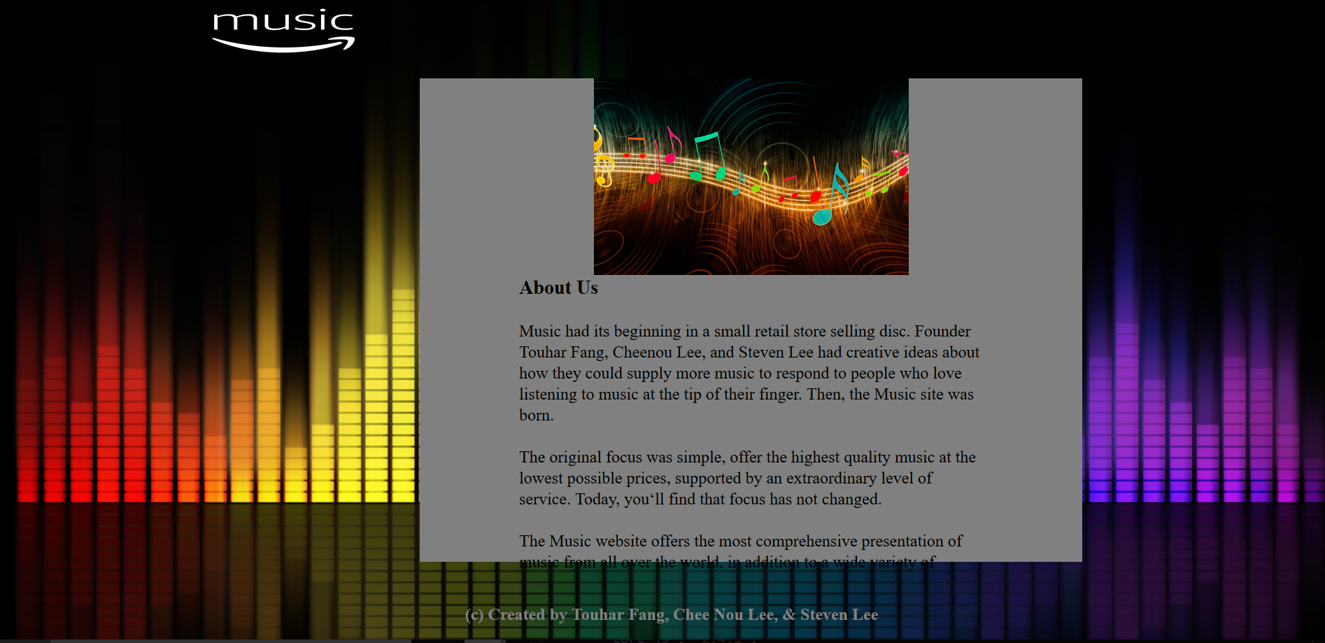

Contact Us page: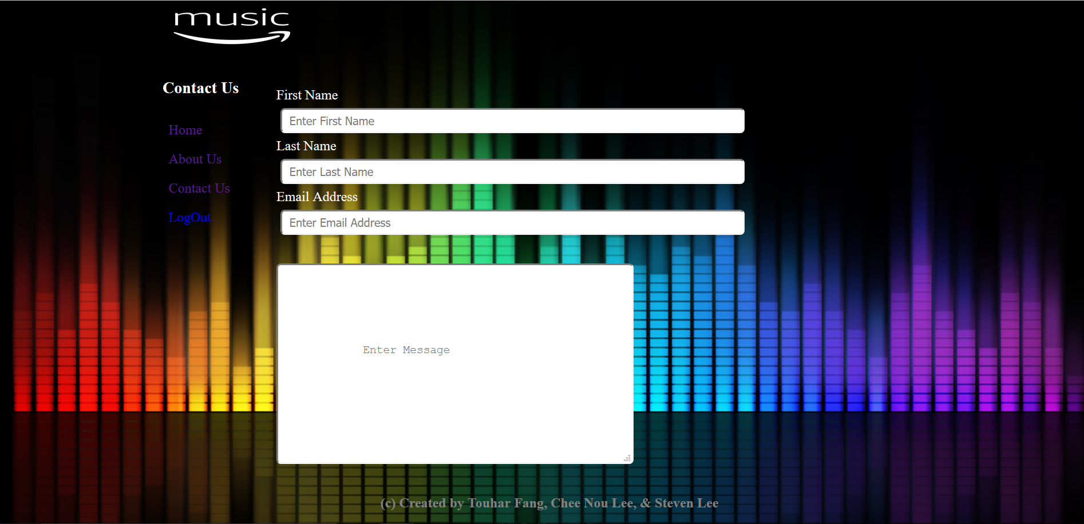

After purchased page: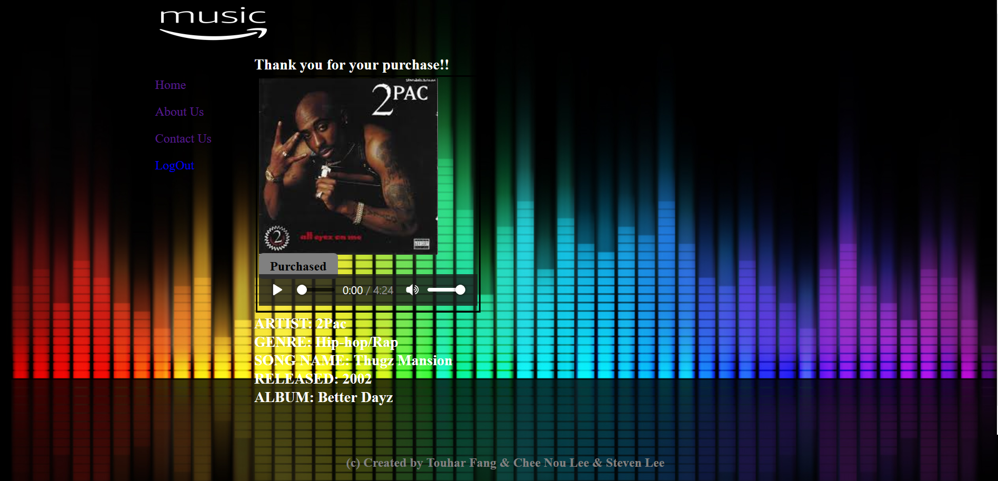

Lessons Learned:

We learned from this project is the toughness and challenge behind building an application website. The reasons follow was making time to work together on this project. If someone one in your team can’t meet up, that can cause delay and issues with the overall project. The other issue is when running the application, someone within your group may not have all of the same files to operate correctly. When we are not together as a group, the issue we have ran into is the time you must wait for another to complete their part of the project. Then towards the end of putting the project together, we would run into problems that would pop up when trying to implement the application website and would have to work backwards to figure out the problem. We believe that that best way to have learned from this experience is to plan this out. Meaning that we should of broke it down more into parts and that every member would understand the needs and tools to complete one part at a time and complete all together in the end.